7/22/2020

SAKHSHI KOUR

HAMMAD AHMED

IBRAHIM RAJPUT

PERSONAL LIBRARY MANAGEMENT SYSTEM

OOP FINAL PROJECT DOCUMENT

**INTRODUCTION**

Inventions improve our lives. It makes our life easier and improve our knowledge. As we all are well known about issues of daily life, which are important to resolve because as the world become modern the things and issues are getting complicated. We all want to see innovation in every aspect of our life. Computer Science and technology has changed the face of the world. Almost in every field(medical, education, etc.) Desktop Applications become so important.

Our project is mainly about the resolution of the books management it is about **PERSNOL LIBRARY MANAGEMENT SYSTEM.** We are going to make this project to resolve the problems of students, teachers and all those who are fond of reading books. They must want a record of books with them. So this is the good way to manage the record of books.

Libraries are a critical part of an educational institute. usually, it has to roll out fine but complex tasks to maintain records of the books. when the institute is focusing on delivering quality educational services, a well-managed library is a part of the service. As smart school operations are trending these days, libraries should be managed electronically to run the smarter institute.

**PROPOSED METHODOLOGY**

Methodology is about how to manage the program. In our project first we show the login page in which there will be two options one is about (new account) and the other is about(existing account). If the user input the first option then it will show then it show the boxes of (Enter name, ID, password). If the user input the second option then it will show then it show the boxes of(ID or Name, password ). After this it shows the 6 menu

* Add Book in this menu there will be sub menu of(book name, author name, book ISBN).
* Remove or Delete Record in this menu there will be a sub menu(Book name).
* Show All Books
* Total books
* Exit
* Main method
* Firstly we will show the Home page

First it shows the home page, in this it shows two buttons one is "New Account" and other one is "Login Account". If you are new then select New Account other wise click on Loin Account.

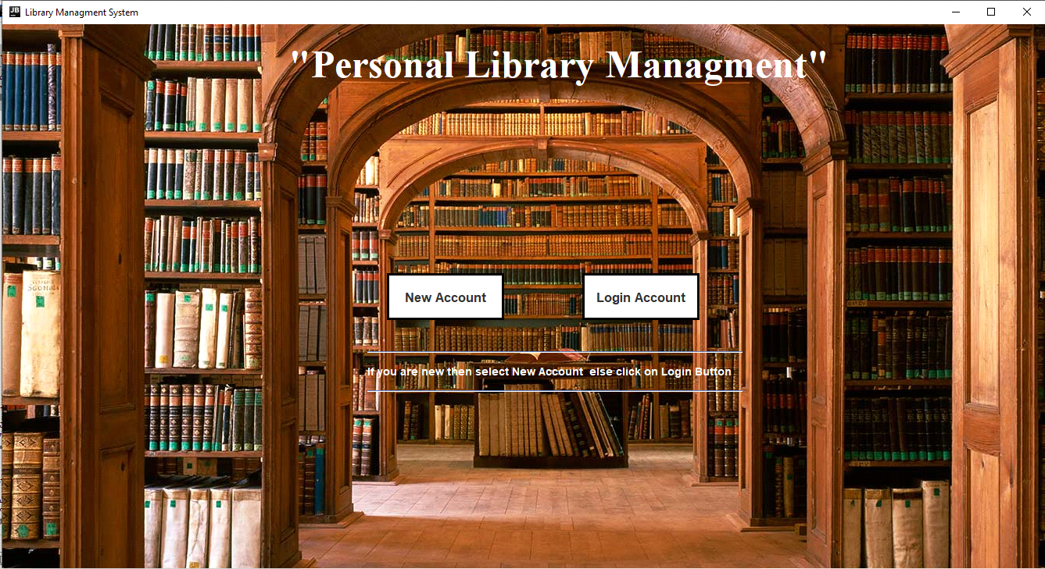

**NEW ACCOUNT**

* For new account

After clicking on new account it shows a new frame, in which it takes three things first it take "Name" then "ID" and then "Password" and after clicking on "Submit" button it creates new account and save this data on database. If you click on the "Back" button it goes on home page. After clicking on "Next" button it shows you a new frame with further updates.

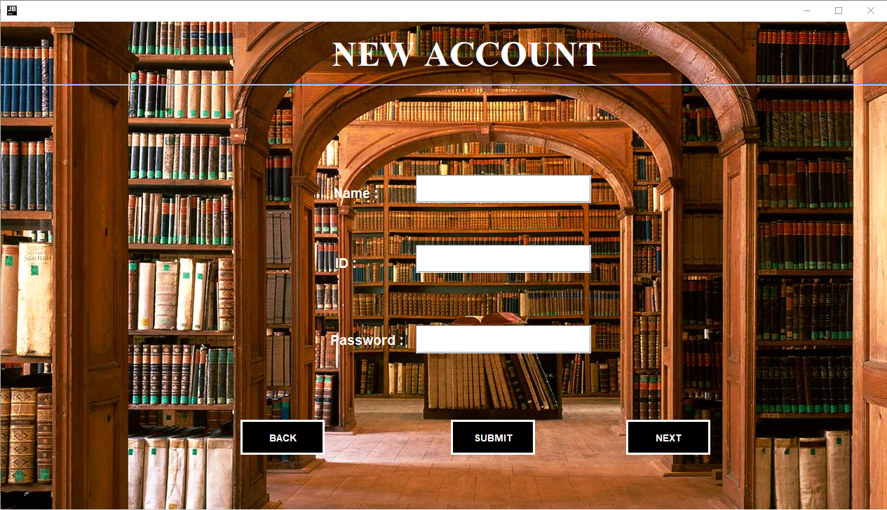

**FURTHER UPDATES**

After clicking on the next button it shows the further updates in which there are four buttons "Add Book", "Remove Book", "Show all Books", "Total Books". In add book it add the info of book given by user. in remove book it delete the record of book. In show all books it shows the table of books which are added and in total books it shows how many books are resent in table.

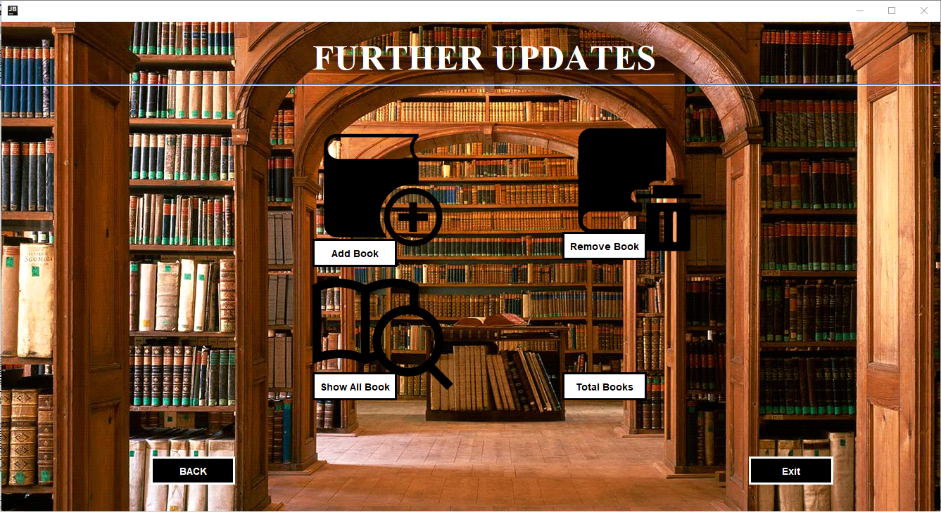

**ADD RECORDS**

For adding the record it takes three things first book name then author name and then ISBN number after this hen click on "Store" button it add the record in database. if user click on "Back" button it goes on new account frame.

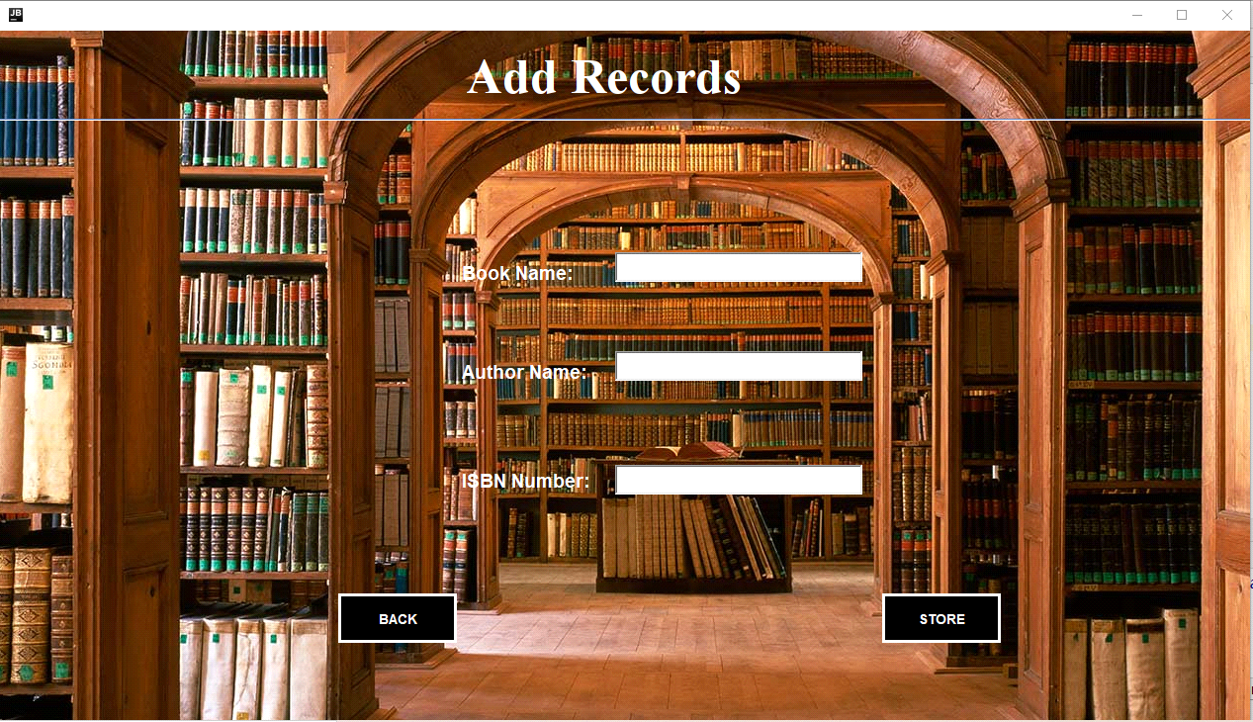

**DELETE RECORDS**

For deleting the record it takes two things first book name and then author name. For deleting the record it is necessary to give, after this it click on "Reset" button it delete the record from database. if user click on "Back" button it goes on new account frame.

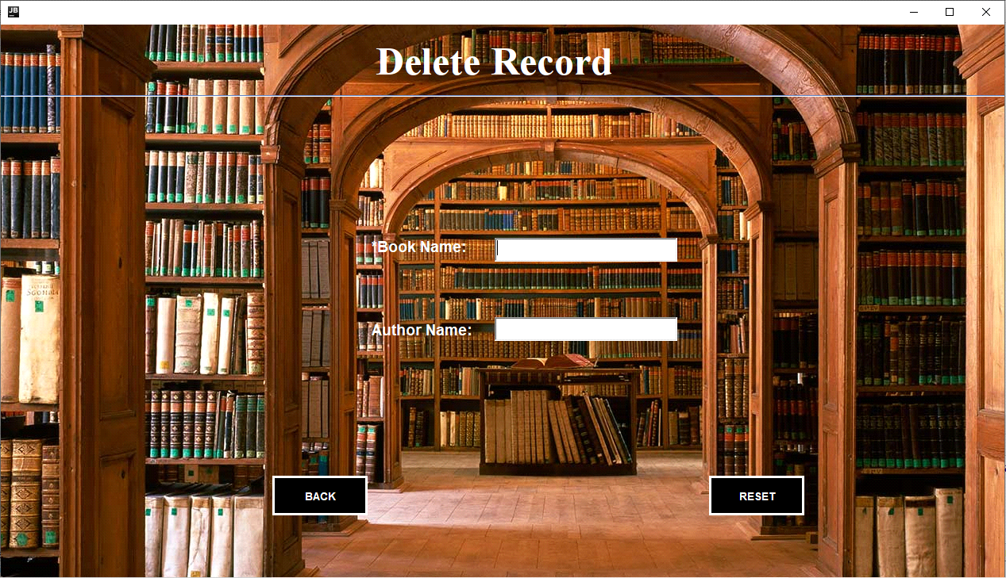

**LIST RECORDS**

This frame will show all the records added in the database in the form of tables.

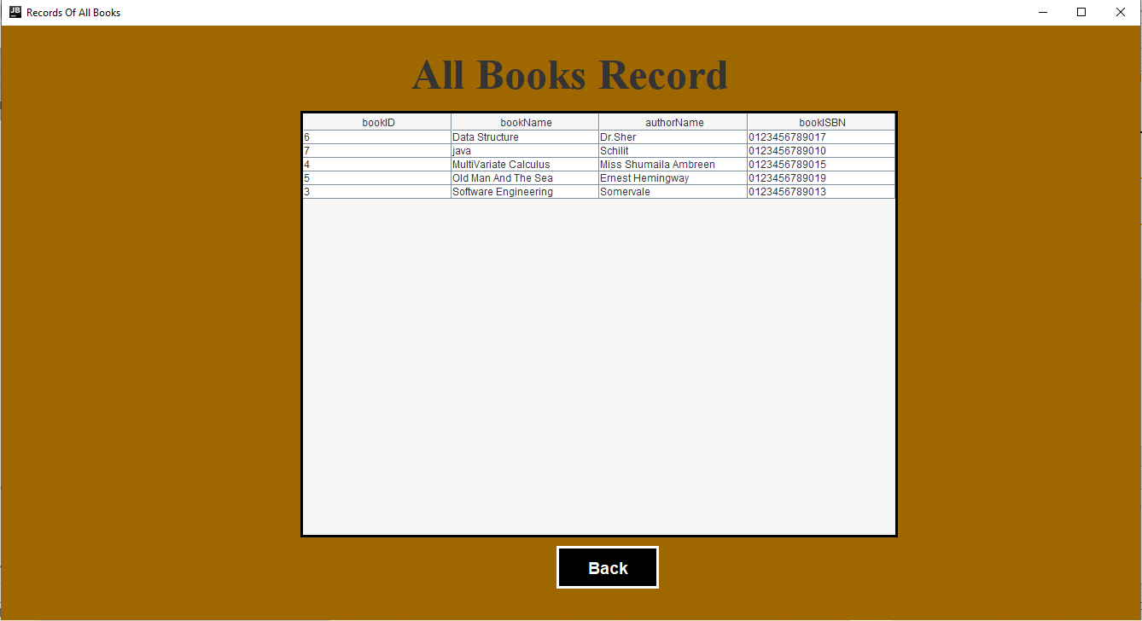

**TOTAL BOOKS**

In this it will show the dialog box of total books present in the table.

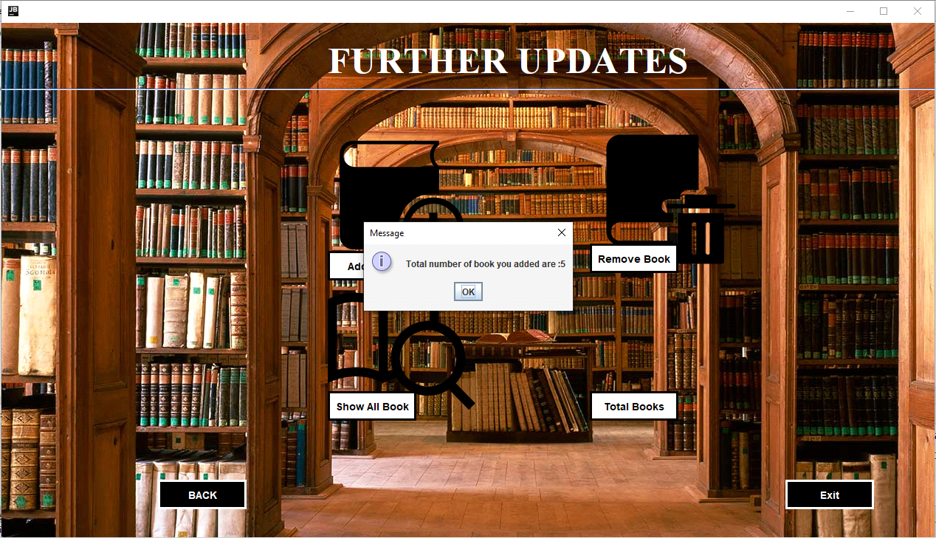

**LOGIN ACCOUNT**

* For existing account / Login Account

After clicking on login account it shows a new frame, in which it takes thwo things first it take "Name" and then "Password" and after clicking on "Submit" button it save this data. If you click on the "Back" button it goes on home page. After clicking on "Next" button it shows you a new frame with further updates.

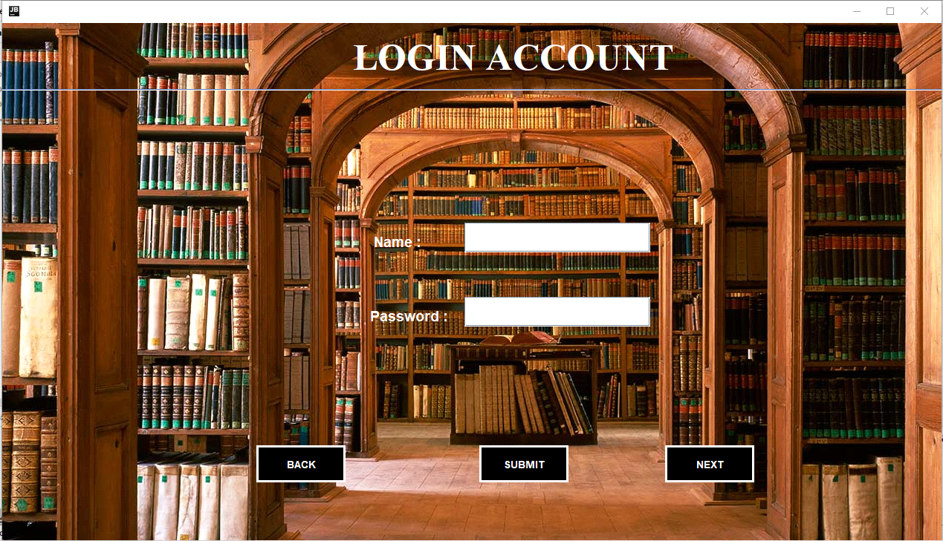

**FURTHER UPDATES**

After clicking on the next button it shows the further updates in which there are four buttons "Add Book", "Remove Book", "Show all Books", "Total Books". In add book it add the info of book given by user. in remove book it delete the record of book. In show all books it shows the table of books which are added and in total books it shows how many books are resent in table.



**ADD RECORDS**

For adding the record it takes three things first book name then author name and then ISBN number after this hen click on "Store" button it add the record in database. if user click on "Back" button it goes on new Login frame.



**DELETE RECORDS**

For deleting the record it takes two things first book name and then author name. For deleting the record it is necessary to give, after this it click on "Reset" button it delete the record from database. if user click on "Back" button it will go on login frame.



**LIST RECORDS**

This frame will show all the records added in the database in the form of tables. And clicking on "Back" button in will go back on login frame.



**TOTAL BOOKS**

In this it will show the dialog box of total books present in the table.



* If user enters new account then it will ask for
* Enter name
* ID
* Password(must be strong or of 8 digits)
* If user enters login account then it will ask for
* ID or Name
* Password(must be strong or of 8 digits)

Then show all these menu

* Add book
* Book Name
* Author Name
* Book ISBN
* Remove or Delete record
* Book Name
* Search Book
* Book Name
* Show All Books
* Total books
* Exit

**PROJECT IDEA**

As earlier mentioned that difficulties faced by book readers in keeping the record of books in problem statement, our application will help readers to keep the record of books, user can add books, remove books, can view the books list.

With the help of personal library management system user can manage their library records permanently without any difficult.

**CONCULSION**

1. After development of this Desktop Application many people get a lot Of benefits like, a person has a large collection of books he/she do not face difficulty in managing and maintaining the record of books.
2. It becomes easy for the users to search books details and total number

of books they have already added in their record.

1. The user of this application can also search for whole details of a book if

he/she forget it.

**THE END.**